Bash Scripting Suite for System Maintenance
Automating backup, system updates, and log monitoring using Linux Bash scripts.
Name: Reetu kanungo
System: Ubuntu (via WSL)
Language: Bash
Date: November 2025

Objective
To design and implement a suite of Bash scripts that automates system maintenance tasks such as backups, system updates, cleanup, and log monitoring, with centralized logging and error handling.

Tools and Environment
• Operating System: Ubuntu (WSL or Linux)
• Language: Bash shell scripting
• Text Editor: Nano or VS Code
• Scheduler: Cron
• Log files: Plain text (.log)

Source Code

backup.sh
#!/bin/bash
set -euo pipefail
trap 'echo "[ERROR] Backup script failed at line $LINENO" | tee -a "$LOG_FILE"' ERR
BACKUP_SRC="$HOME/Documents"
BACKUP_DEST="$HOME/backups"
LOG_FILE="$HOME/backup.log"
TIMESTAMP=$(date +"%Y-%m-%d_%H-%M-%S")
mkdir -p "$BACKUP_DEST"
echo "[$TIMESTAMP] Starting backup..." >> "$LOG_FILE"
tar -czf "$BACKUP_DEST/backup_$TIMESTAMP.tar.gz" "$BACKUP_SRC" 2>> "$LOG_FILE"
echo "[$TIMESTAMP] Backup completed successfully." >> "$LOG_FILE"

update_cleanup.sh
#!/bin/bash
set -euo pipefail
trap 'echo "[ERROR] Update script failed at line $LINENO" | tee -a "$LOG_FILE"' ERR
LOG_FILE="$HOME/update_cleanup.log"
TIMESTAMP=$(date +"%Y-%m-%d %H:%M:%S")
echo "[$TIMESTAMP] Starting system update..." >> "$LOG_FILE"
sudo apt update -y && sudo apt upgrade -y >> "$LOG_FILE" 2>&1
echo "[$TIMESTAMP] System updated successfully." >> "$LOG_FILE"
echo "[$TIMESTAMP] Performing cleanup..." >> "$LOG_FILE"
sudo apt autoremove -y && sudo apt clean >> "$LOG_FILE" 2>&1
echo "[$TIMESTAMP] Cleanup completed." >> "$LOG_FILE"

log_monitor.sh
#!/bin/bash
set -euo pipefail
trap 'echo "[ERROR] Log monitor failed at line $LINENO" | tee -a "$ALERT_LOG"' ERR
LOG_FILE="/var/log/syslog"
ALERT_LOG="$HOME/log_alerts.log"
KEYWORDS=("error" "fail" "critical")
TIMESTAMP=$(date +"%Y-%m-%d %H:%M:%S")
echo "[$TIMESTAMP] Monitoring logs for issues..." >> "$ALERT_LOG"
FOUND_ISSUE=false
for keyword in "${KEYWORDS[@]}"; do
if grep -iq "$keyword" "$LOG_FILE"; then
echo "[$TIMESTAMP] Found keyword: $keyword" >> "$ALERT_LOG"
grep -i "$keyword" "$LOG_FILE" >> "$ALERT_LOG"
FOUND_ISSUE=true
fi
done
if [ "$FOUND_ISSUE" = true ]; then
echo "[$TIMESTAMP] ALERT: Issues detected in system logs!" >> "$ALERT_LOG"
else
echo "[$TIMESTAMP] No critical issues found." >> "$ALERT_LOG"
fi

maintenance_suite.sh
#!/bin/bash
LOG_DIR="$HOME/maintenance_logs"
mkdir -p "$LOG_DIR"
SUITE_LOG="$LOG_DIR/suite_$(date +%Y-%m-%d).log"
log() {
echo "[$(date +'%Y-%m-%d %H:%M:%S')] $1" | tee -a "$SUITE_LOG"
}
while true; do
clear
echo "======================================"
echo " SYSTEM MAINTENANCE SUITE "
echo "======================================"
echo "1. Run Backup"
echo "2. Update and Clean System"
echo "3. Monitor Logs"
echo "4. View Suite Log"
echo "5. Exit"
echo "--------------------------------------"
read -p "Enter your choice [1-5]: " choice
case $choice in
1)
log "Running backup script..."
if ./backup.sh; then
log "Backup completed successfully."
else
log "Backup failed!"
fi
read -p "Press Enter to continue..."
;;
2)
log "Starting system update & cleanup..."
if ./update_cleanup.sh; then
log "System update and cleanup completed."
else
log "Update & cleanup failed!"
fi
read -p "Press Enter to continue..."
;;
3)
log "Monitoring system logs..."
if ./log_monitor.sh; then
log "Log monitoring completed."
else
log "Log monitoring failed!"
fi
read -p "Press Enter to continue..."
;;
4)
echo "--------------------------------------"
echo "Viewing Suite Log:"
cat "$SUITE_LOG"
echo "--------------------------------------"
read -p "Press Enter to return to menu..."
;;
5)
log "Exiting Maintenance Suite."
exit 0
;;
*)
echo "Invalid choice!"
read -p "Press Enter to continue..."
;;
esac
done

Screenshots
Include the following screenshots in your report:

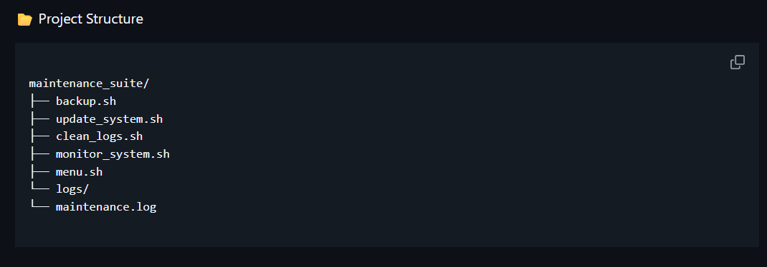

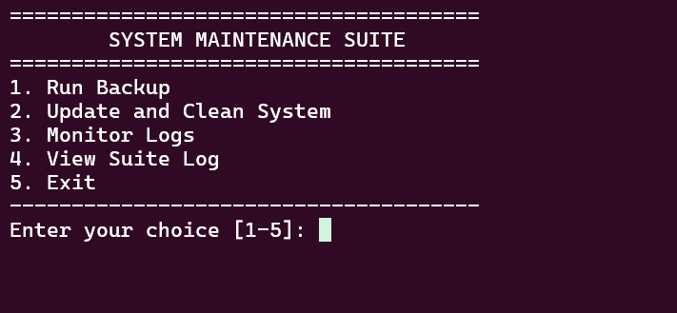
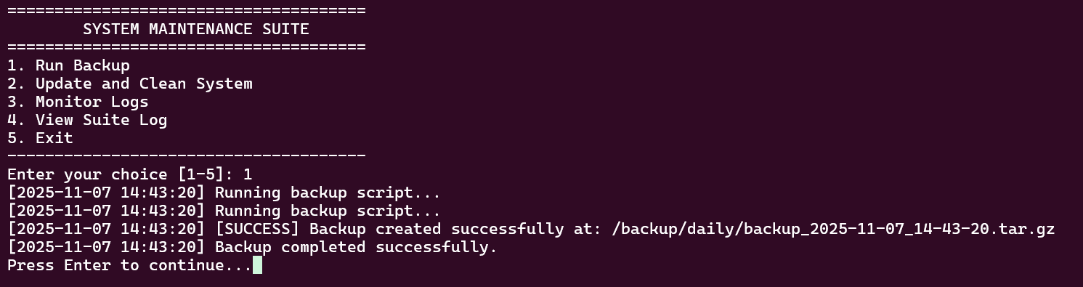
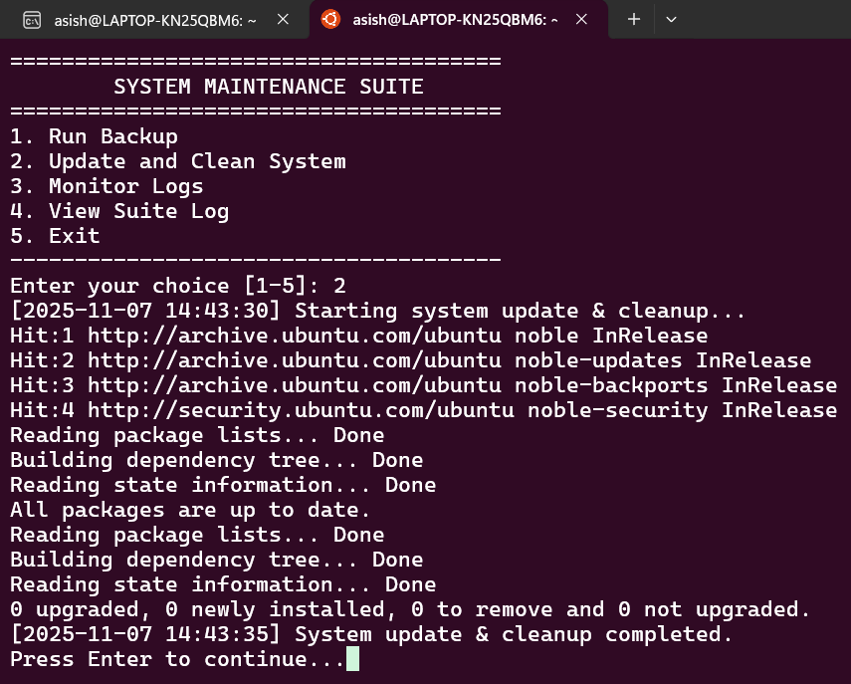

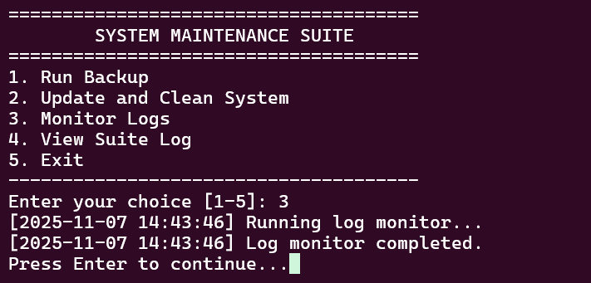

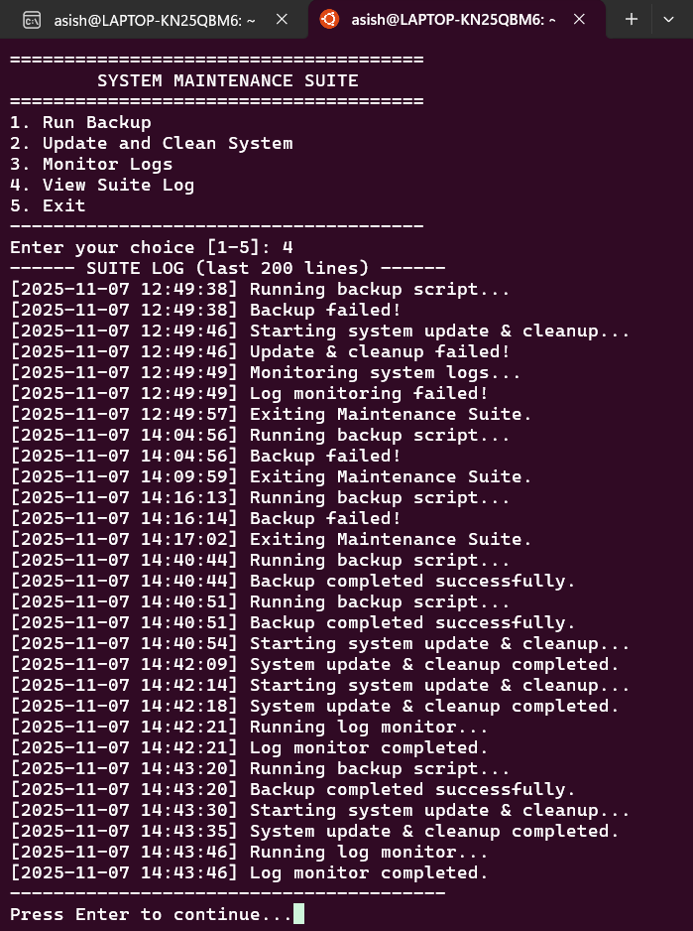

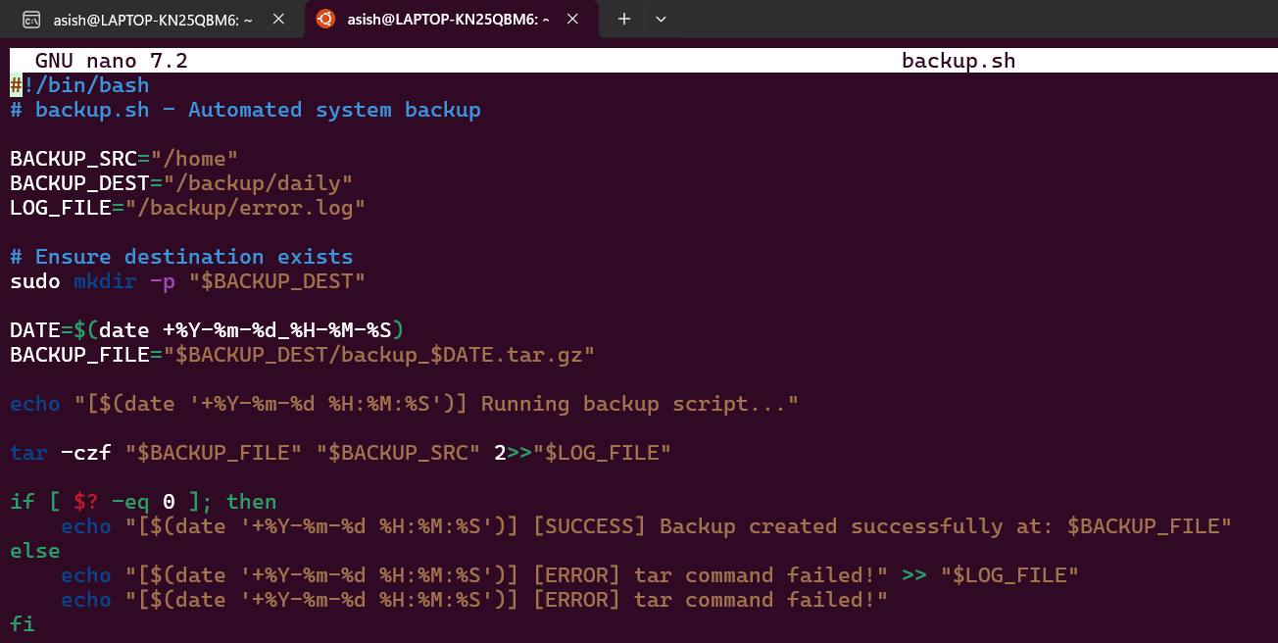
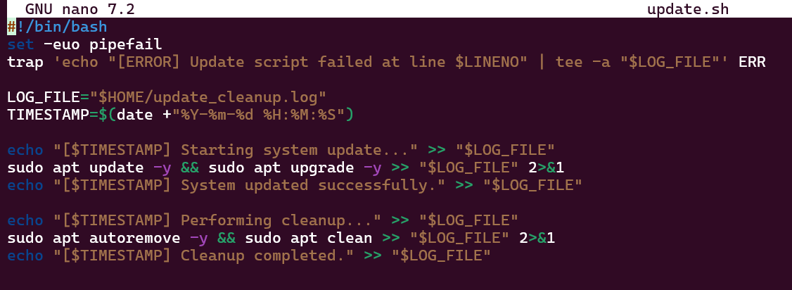
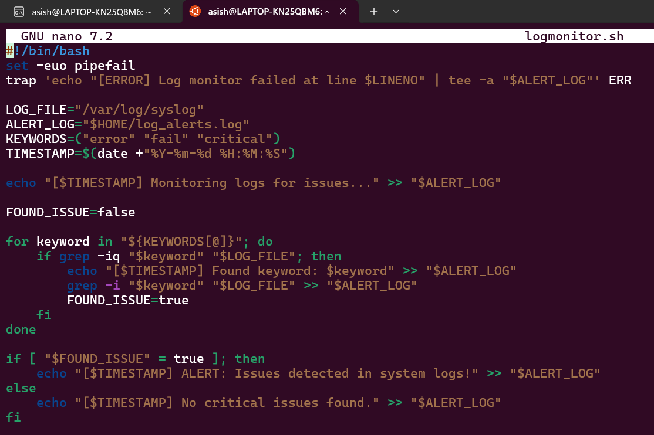

Conclusion
The Bash System Maintenance Suite successfully automates essential system tasks such as backups, updates, cleanup, and log monitoring with robust error handling and logging. It demonstrates efficient Linux administration through Bash scripting.

